|  |  |  |
| --- | --- | --- |
|  | **Rochester Institute of Technology**  **Golisano College of Computing and Information Sciences**  **School of Interactive Games and Media**  **2145 Golisano Hall – (585) 475-7680** |  |

**Data Structures & Algorithms for Games & Simulation II**

**IGME 309**

**First exam – Practical (version s)**

I’ve included a solution under the _Binary folder. Please take a look at that before continuing reading this document. You are not allowed to open past projects.

Right out of the box you will begin with this:

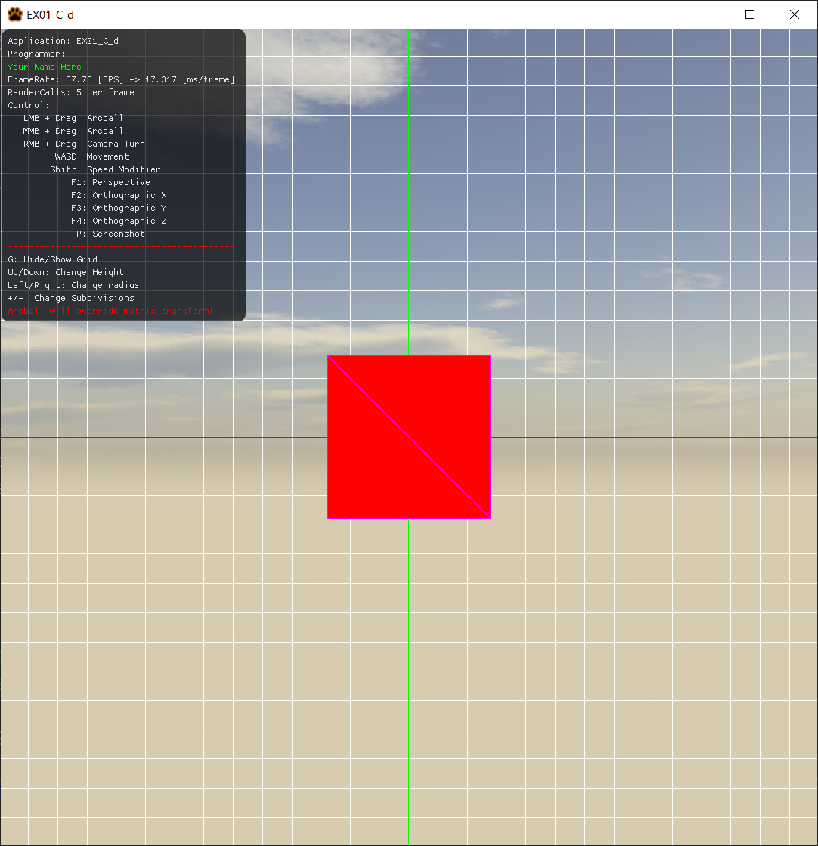

You are working on a drawing app that will display a pencil model that can be dynamically generated and modified into different shapes. The end result should look like this:

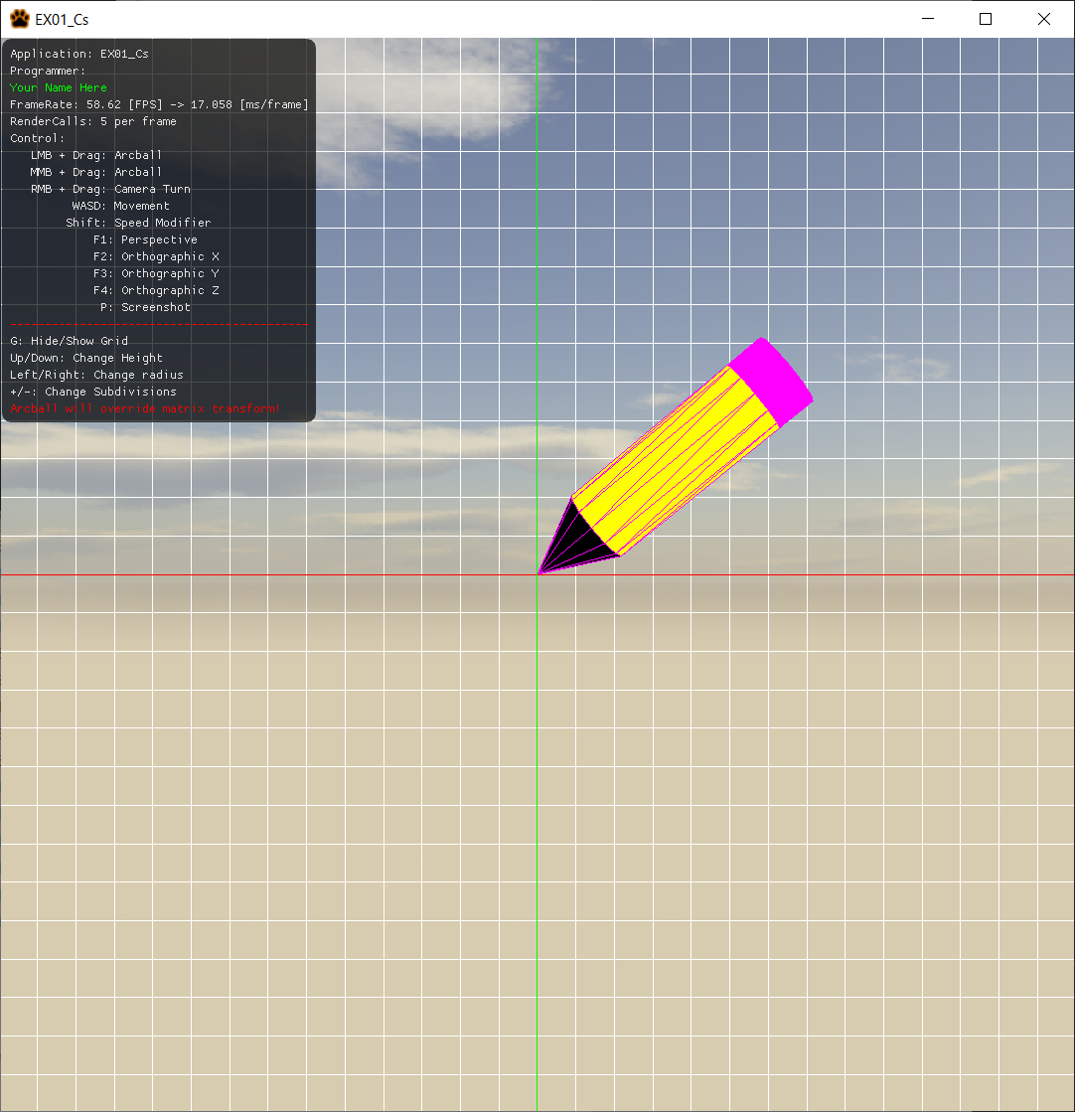

From the starter code there are some things you need to do:

1. Modify the MyMesh.cpp GeneratePencil method to generate the shape
   1. All 3 shape-components will have the same subdivision level
   2. The Tip cone part will have always a height of twice the radius
   3. The Eraser cylinder part will always have a height equal to the radius
   4. The a_fHeight argument is JUST the yellow cylinder
   5. Internal faces are not to be constructed (ie. there are no circles between the cone and the yellow cylinder, nor between the yellow and the magenta cylinders)
2. Once you have a pencil make sure it starts drawing a spiral as in the demo
   1. It will display fCumulative units to the right each draw call
   2. It will revolve around the origin fCumulative * fFPS times each draw call in the Z axis.

Tips

1. There are pragma regions for your convenience, anything inside a DOES NOT NEED CHANGES region is bug-free ready to use
2. For your convenience an arcball has been added to the pencil shape, if you modify its orientation this transform will override any m_m4Model transformations you have created.
3. You can use whatever colors you want for the parts but they need to be distinct from each other.
4. Your files need to compile, if the code does not compile it gets an automatic 0, its better for you to comment the faulty lines and receive partial credit than no credit at all.
5. Memory is handled for you unless you make new variables.
6. There is no need to calculate a clock or anything of the sort; the fCumulative variable will be time dependent and its ready to use.
7. The only files you need to modify is:
   1. MyMesh.cpp
      * GeneratePencil(…)
   2. AppClass.cpp
      * Update(…)
8. You are allowed to add more variables and methods as needed. But you will **only submit the files MyMesh.cpp and AppClass.cpp** in a single .zip file in the odd case that you are adding more variables on other files make sure you are giving me all the files I need to grade.

Grade:

25 points - Cone tip

25 points - Cylinder pencil

25 points - Cylinder Eraser (does require a top face)

15 points - Transformation drawing the spiral

10 points - You submit only the MyMesh.cpp and AppClass.cpp zipped (unless you really needed to include more files for a reason, you need to tell us why in the comments)

***Submit to the dropbox labeled Exam 1 –Practical***

The required submission asks only for a single unzipped file containing MyMesh.cpp and AppClass.cpp, not the whole solution, it should be no larger than 10kb, if you are using extra files for creating variables and such, please include those files as well in the zipped file. The content of your submission should look like this (routes might be different):

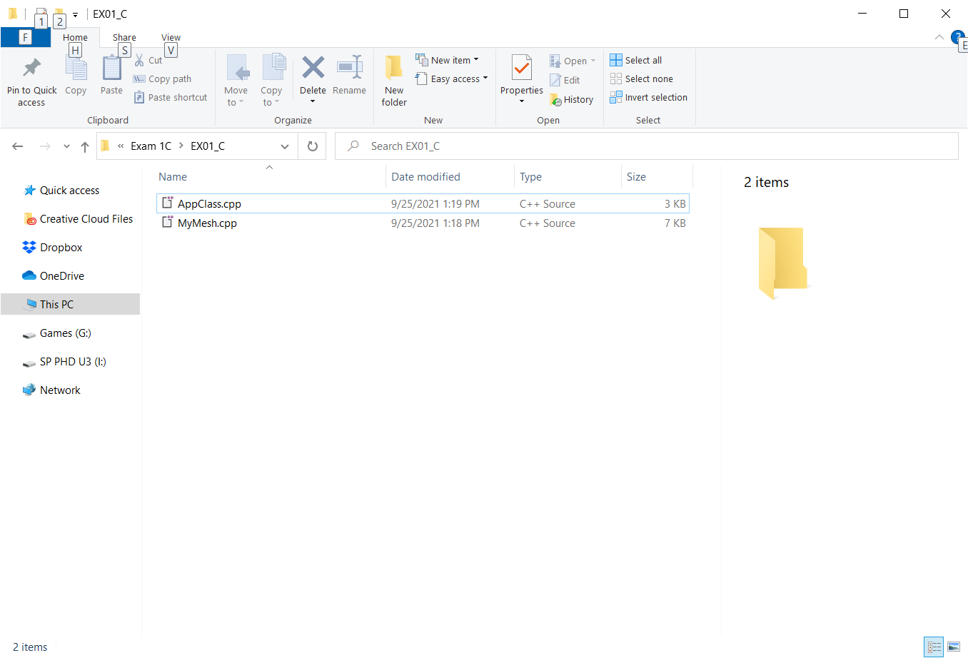

After you submit your file it is your responsibility to download your submission and make it is what you worked on and not the starter code, **it has happened to other students before, do not let it happen to you.**